**No hp +62 895-3063-0024 bela / Nabila aullia**

**No hp +62 831-6915-5391 ibukibuk =//// syaqila rek-BCA**

**-------------------------------------------------------------------------------------------**

**No hp +62 882-8740-0176 dewi = get contak nabila aullia**

**No hp +62 882-6817-5627 ngaku dewi jg di get contak salsa saqila**

**No hp 082185555182 ngaku ita = nama di dana N****a A****a / inisial nabila auliya/ get contak nabila aulia**

**No 085266665681 ngaku ita juga**

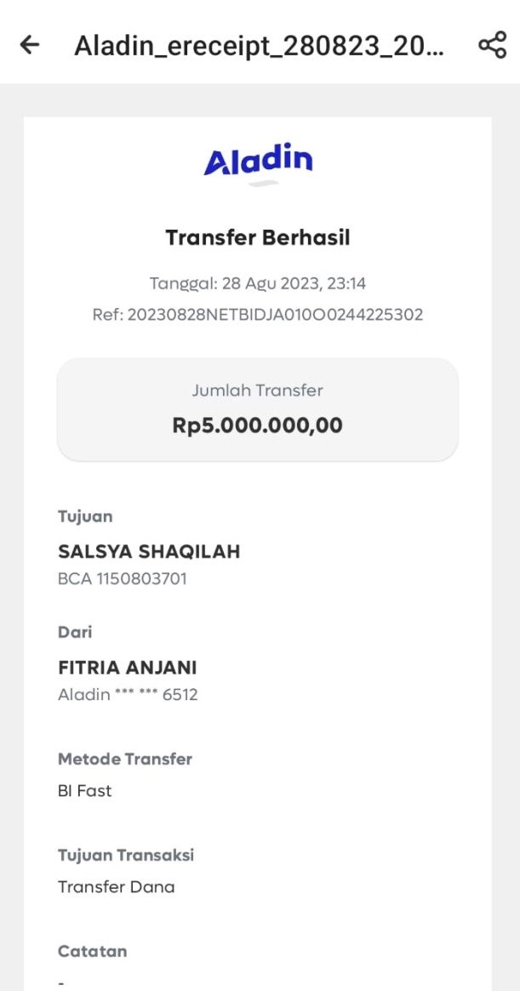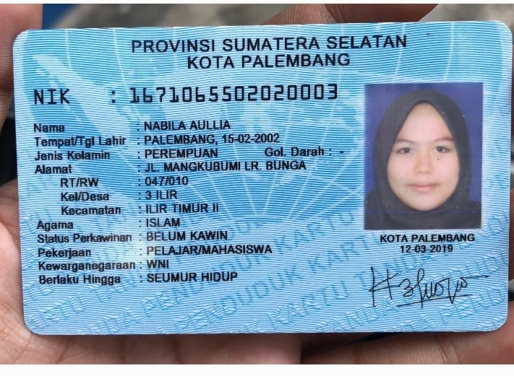

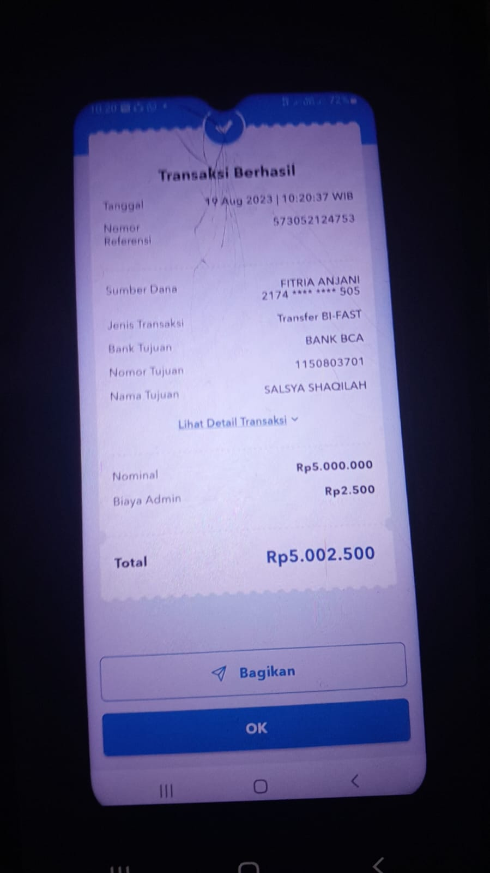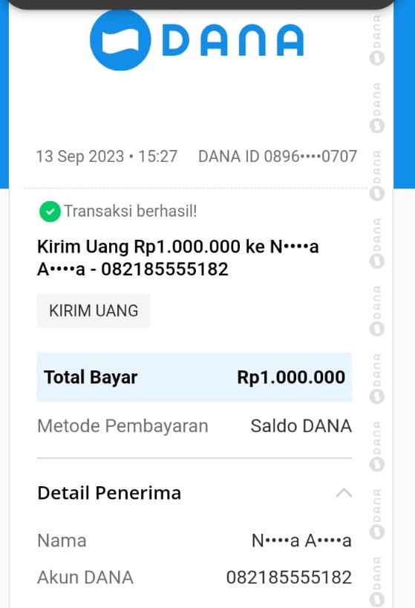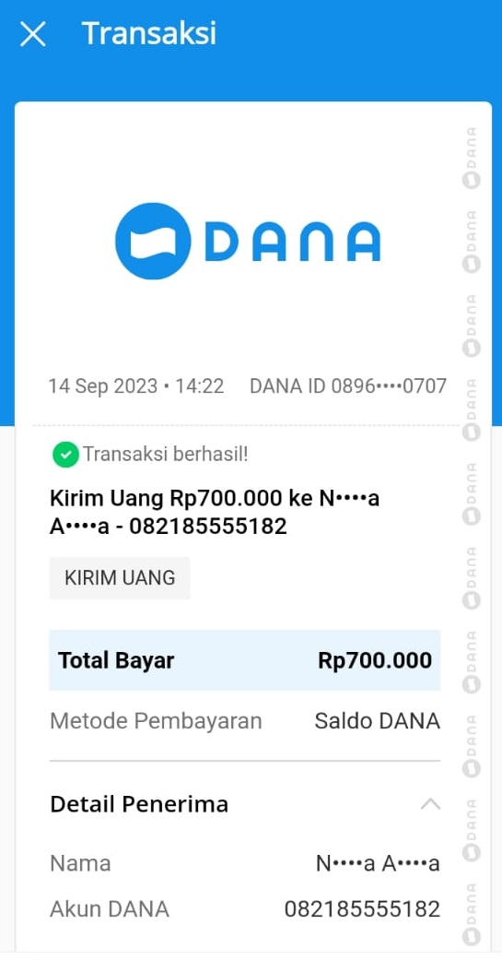

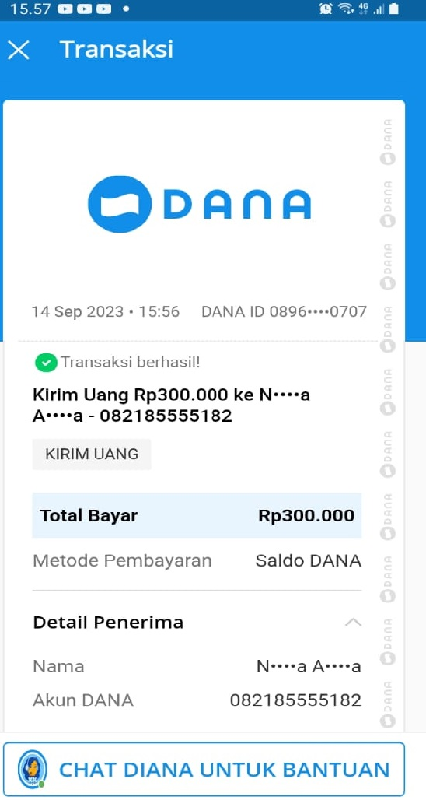

**Halaman Screen shoot chat dan get contack**

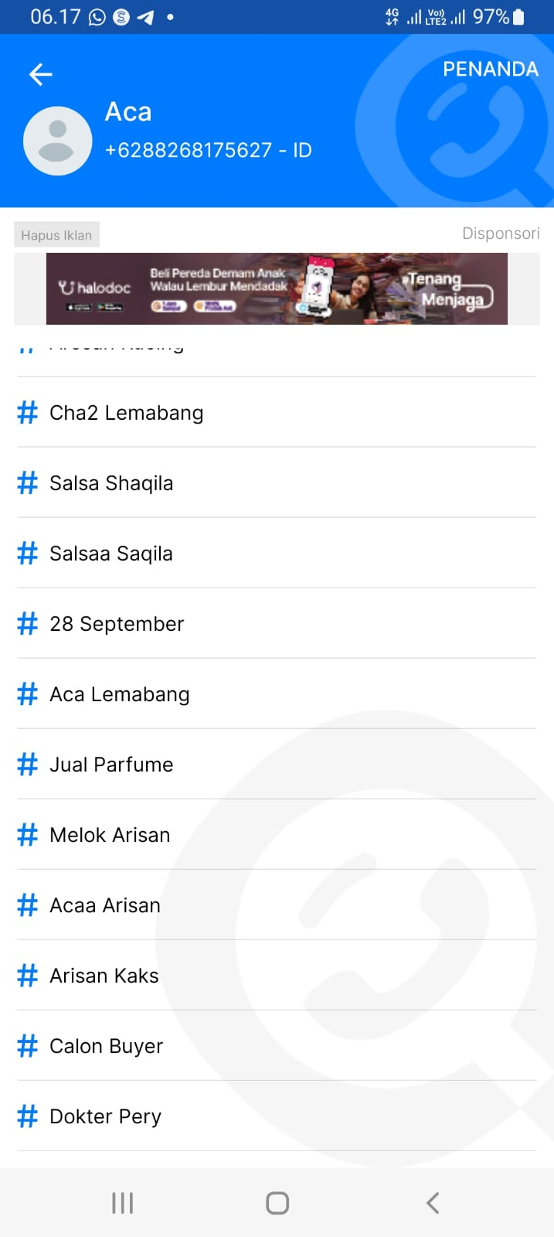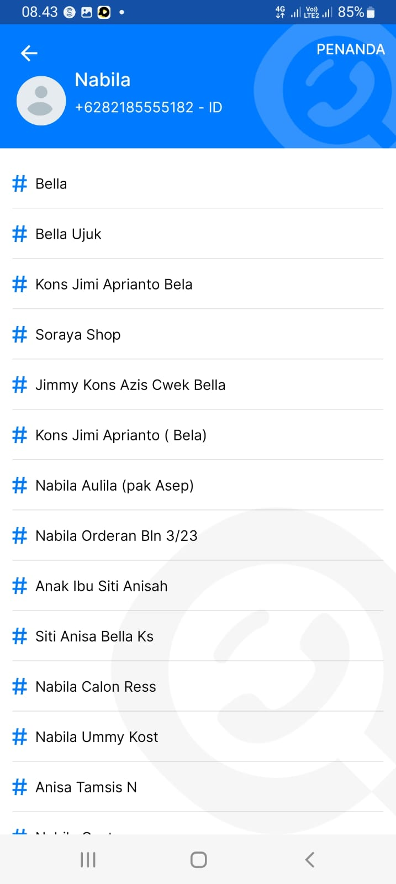

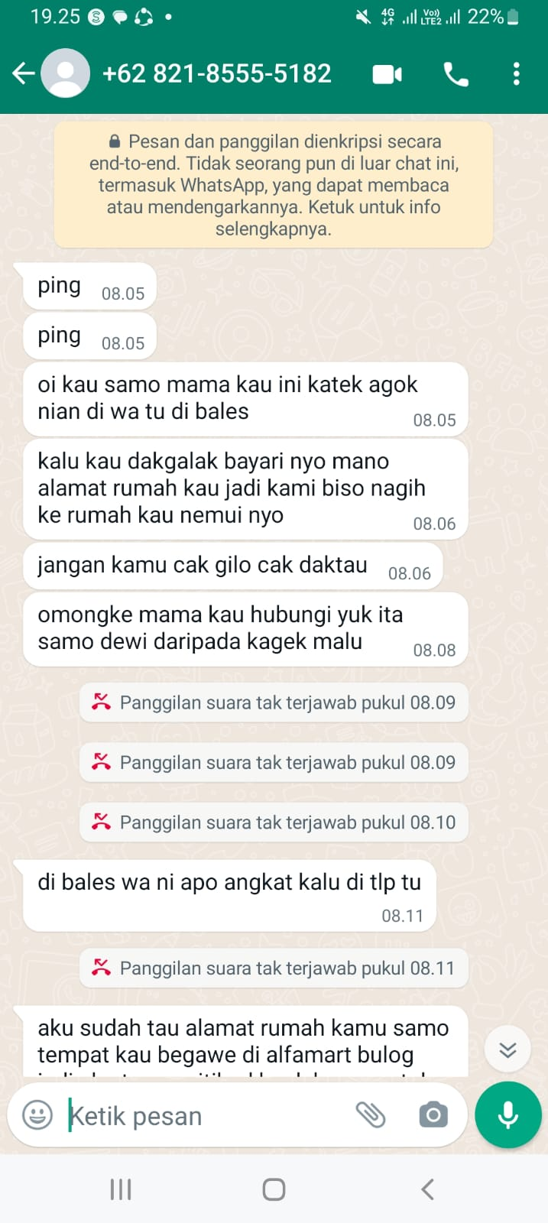

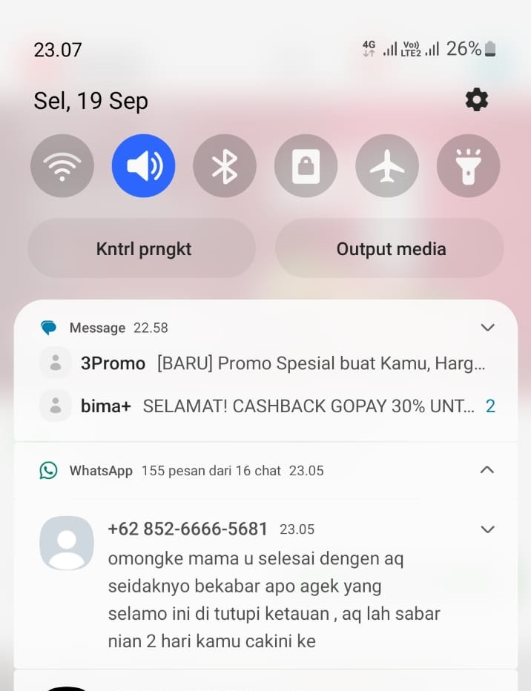

**halaman foto**

